OWASP Juice Shop:

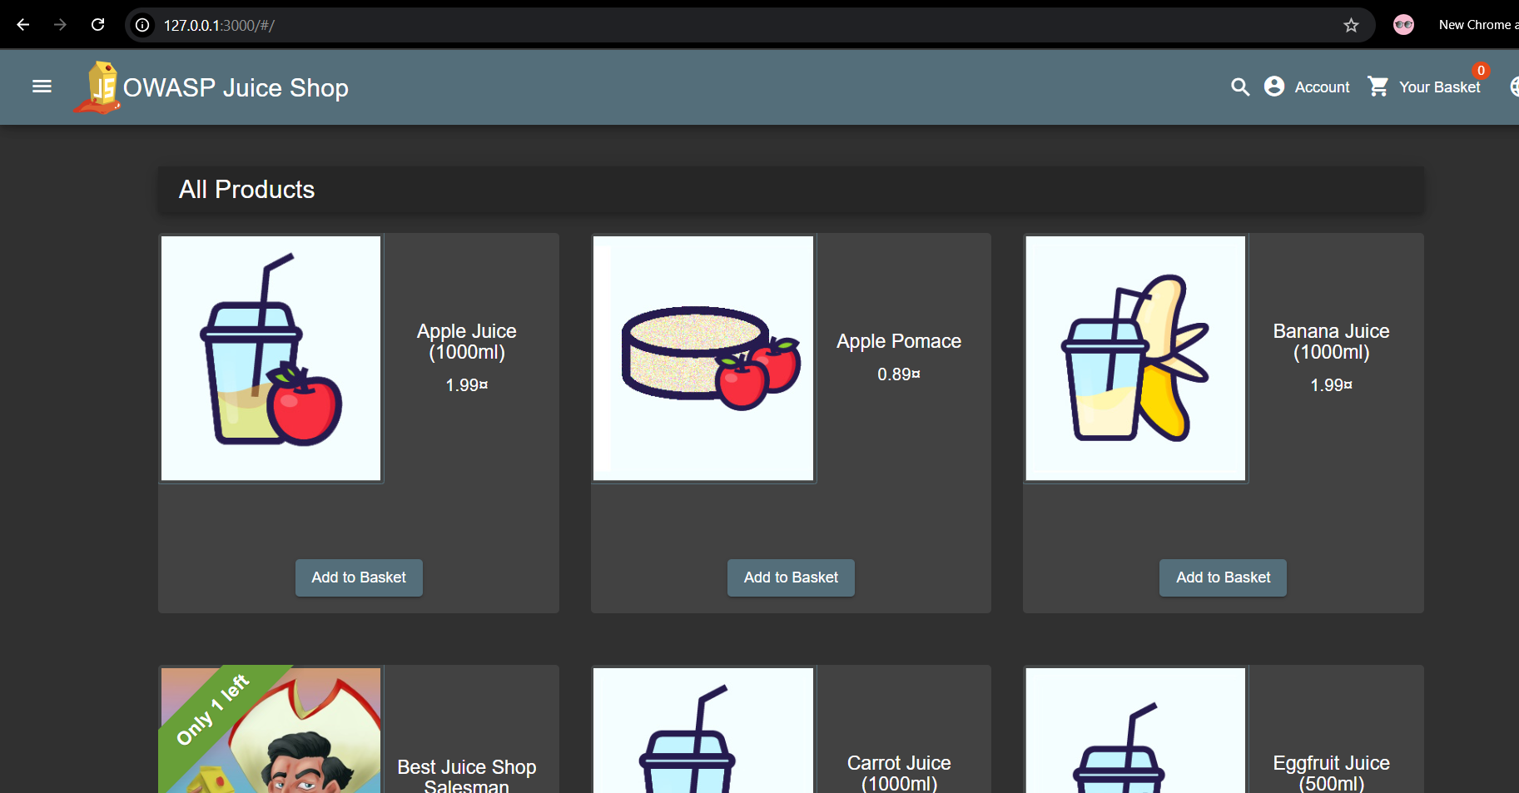

Attack Report:

Practical Applications/Implementations in Daily Life of this Lab:
These labs demonstrate actual issues that might arise on websites. They aid in increasing our awareness of how hackers can execute malicious code, fool individuals into clicking on malicious links, or access personal data. Gaining this knowledge enables security teams and developers to address issues early and protect their customers.

Lab 01: Missing Encoding
When I opened the Photo Wall site, I saw that one picture was not loading. I checked the code using Inspector tool pre-bult in browsers and discovered a # in the picture link. I found that # should be typed as %23 by using the (encoder-decoder website: meyerweb.com/eric/tools/dencoder/). That means, the site was not properly encoded, which was prevnting the image from loading.
The image failed to load, and the browser could not be able to interpret input as code. Missing encoding (CWE-116) is risky because it allows attackers to run malicious code or steal user data because a website fails to process special symbols correctly.
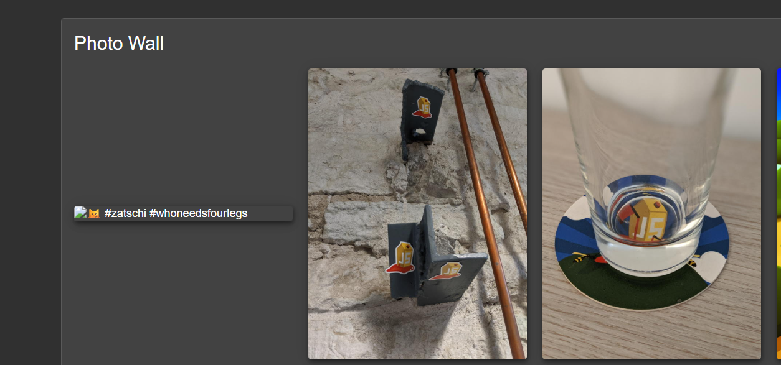

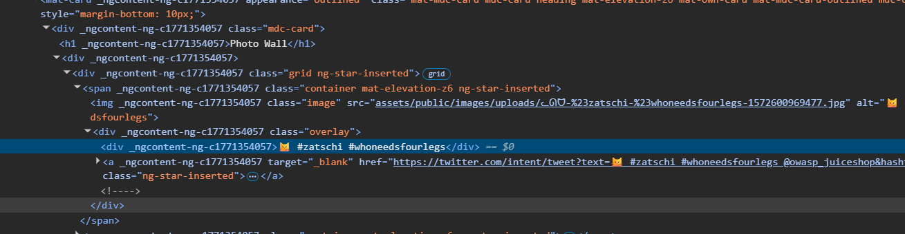

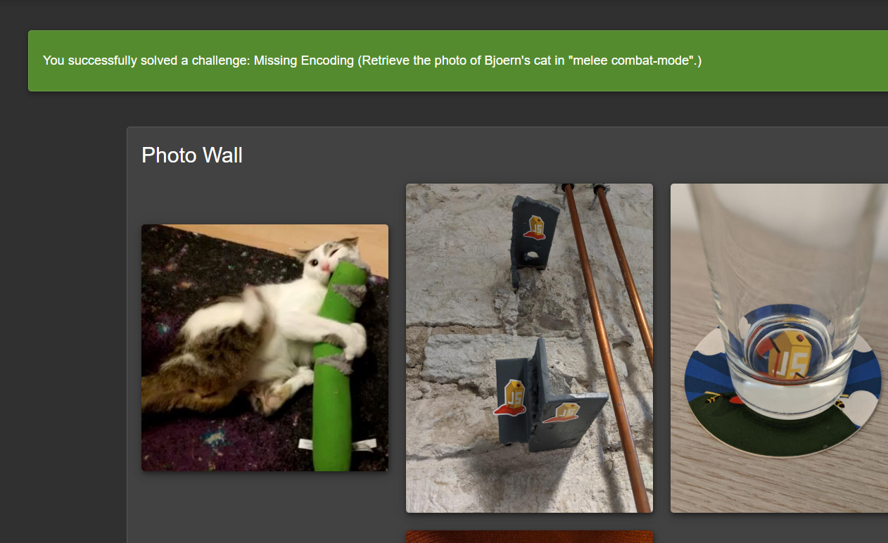

References:
https://www.youtube.com/watch?v=W7Bt2AmYtao
https://cwe.mitre.org/data/definitions/116.html

Lab 02: Outdated Allowlist [Redirection]
I looked at the code using Inspector tool pre-built in web browser [to see the source code] and discovered a redirect link in main.js. I then added the URL of Blockchain.info found in main.js after [http://127.0.0.1:3000/ - the website of OWASP juice shop] in the browser. And then upon opening it, I was redirected to blockchain.com. This is harmful, hackers can use it to direct users to malicious websites where they have uploaded malicious code if the user by mistakenly download it, then it might be possible that they could be hacked.
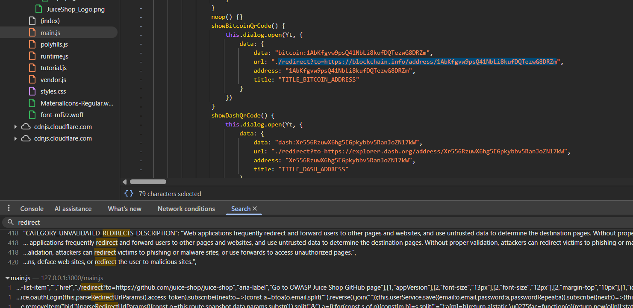

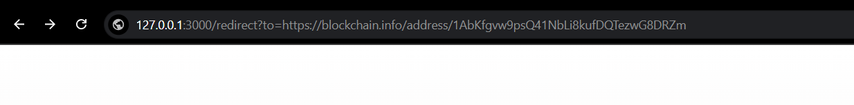
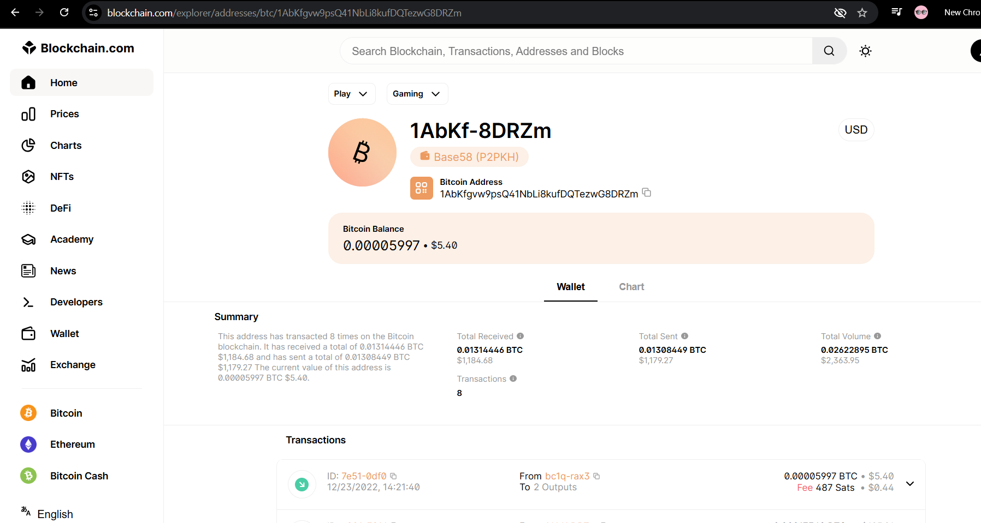

References:
https://www.youtube.com/watch?v=TEdZAXuTfpk

Lab 03: Confidential Document Exposure
I scrolled to the About Us page from the OWASP Dashboard and then clicked on the green link[“Check out our boring terms of use if you are interested in such lame stuff. ”]. It loaded /ftp/legal.md in new tab. I have captured on these all in Burp. After that, I tried /ftp and examined it in Burp Suite. It responded 200 Ok, then I further scrolled to the response provided by server. I found the name of file “acquisitions.md”. I opened /ftp/acquisitions.md. There were other additional files also might contain confidential private data. These files shouldn't be available to the public, this is dangerous.
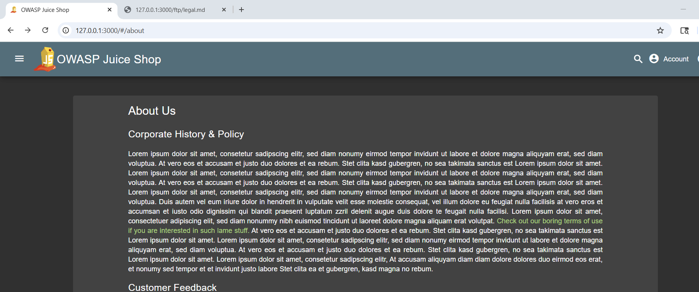

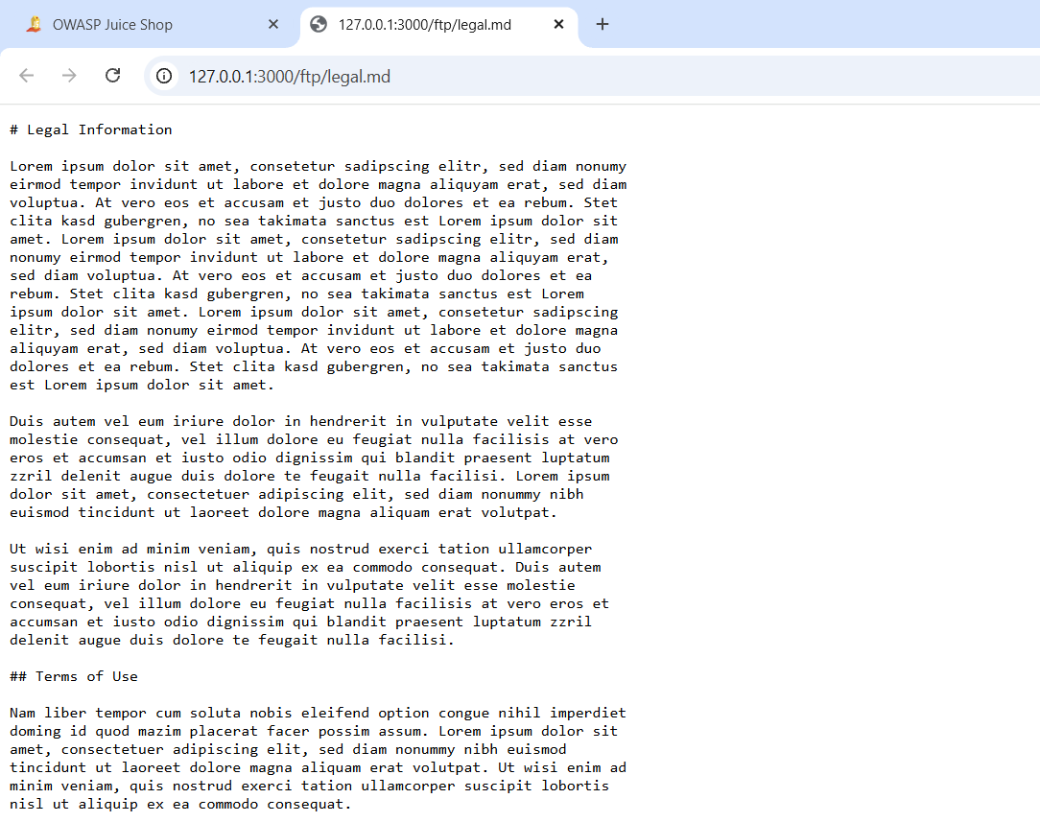
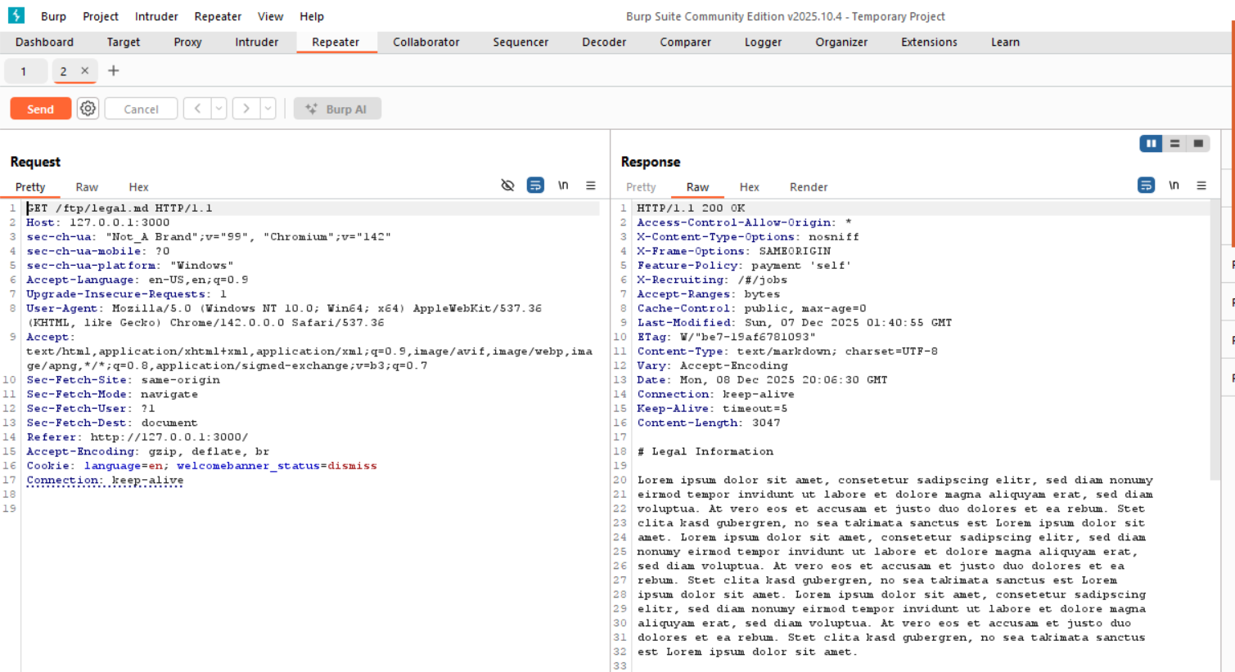

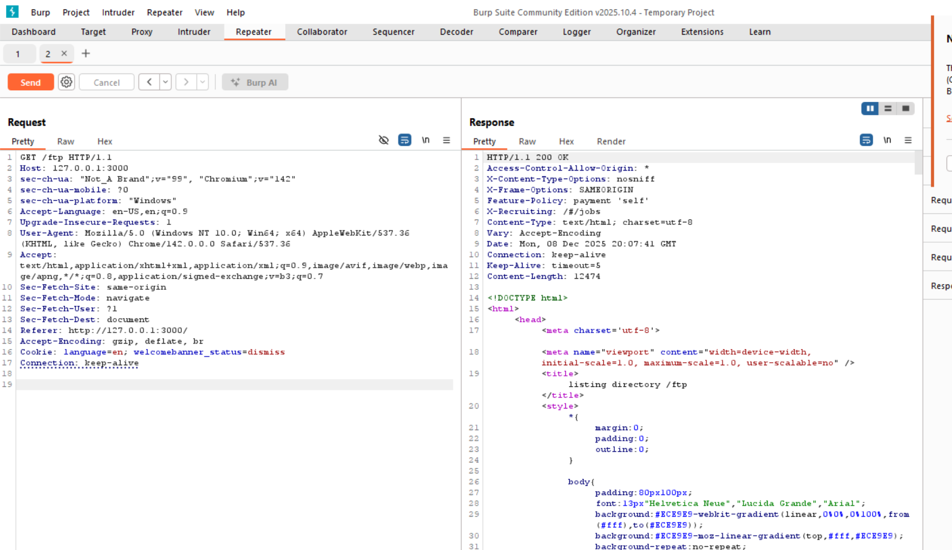

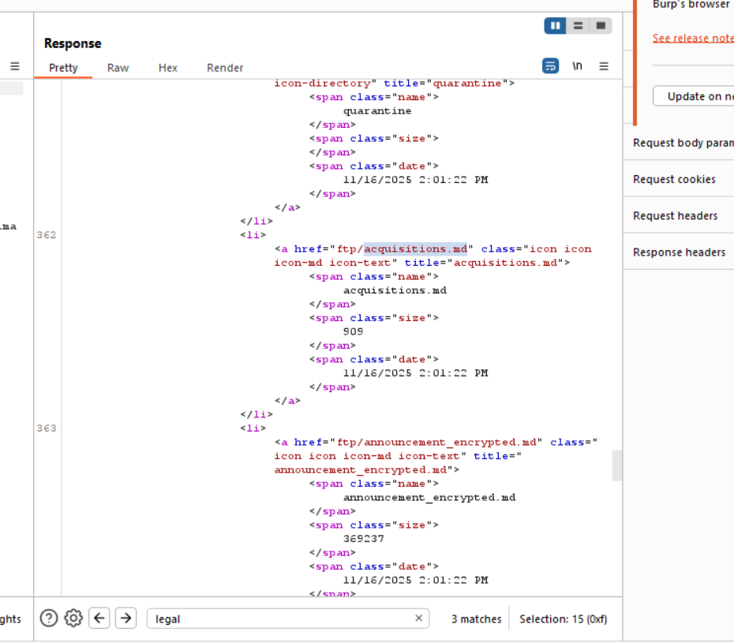

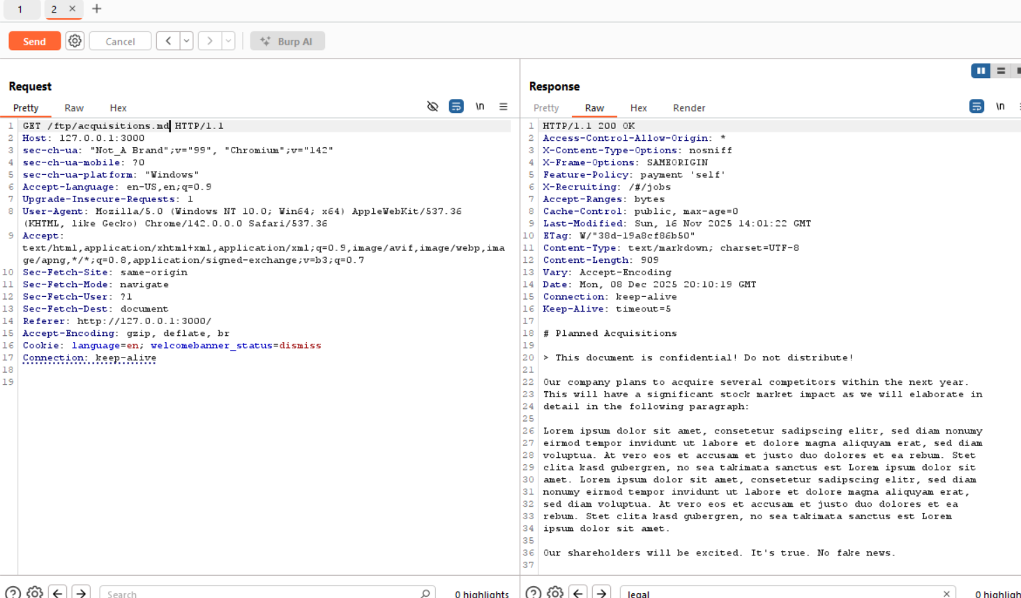

References:
https://www.youtube.com/watch?v=Yi7OiMtzGXc

